Secure Backup Tool | Python Automation Project
Automated File Backup with SHA-256 Integrity Verification & Logging

1. Project Overview
The Secure Backup Tool is a Python automation script that provides a reliable, verifiable, and logged file backup solution. The tool was developed in a step-by-step iterative manner, starting from a simple folder exploration script and evolving into a fully featured backup utility with cryptographic integrity checking and persistent logging.
This document walks through each development stage, explains the purpose of each component, and presents the screenshots that demonstrate the tool working in a real environment.
Project Objectives
1. | Scan and list all files in a target folder with their sizes
2. | Create a timestamped ZIP archive of all files in the folder
3. | Generate a SHA-256 cryptographic hash to verify backup integrity
4. | Save the hash to a companion .sha256 file for future verification
5. | Log every backup operation with timestamp, file count, size, and hash

Stage 1 — Folder Explorer (explore.py)
The first stage of the project involved building a folder exploration script (explore.py) that scans a target directory and lists every file along with its size in kilobytes. This served as the foundation for understanding the file system structure before performing any backup operations.
What this Script does
- Iterates through all items in the target directory using pathlib.Path
- Distinguishes between files ([FILE]) and subdirectories ([DIR])
- Calculates and displays the size of each file in KB
- Prints a total size summary at the end
- Creates the backups/ directory if it does not already exist
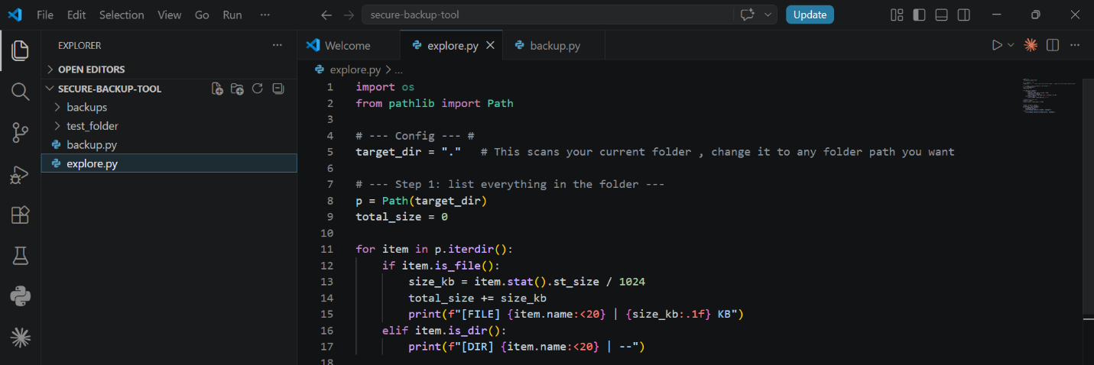Figure 1 — explore.py: Folder scanner showing file listing logic with size calculation
The screenshot above shows the complete explore.py script open in VS Code. The script uses pathlib to iterate the directory, distinguishes files from directories, and calculates file sizes. This exploration phase helped identify what files needed to be backed up and verified the folder structure was correct before adding backup logic.

Stage 2 — First Backup Run
With the folder structure confirmed, the first version of backup.py was written. This version used shutil.copytree to copy the entire source folder into a timestamped subdirectory inside the backups/ folder. The timestamp format used was YYYY-MM-DD_HH-MM-SS, ensuring every backup is uniquely named and sortable by date.
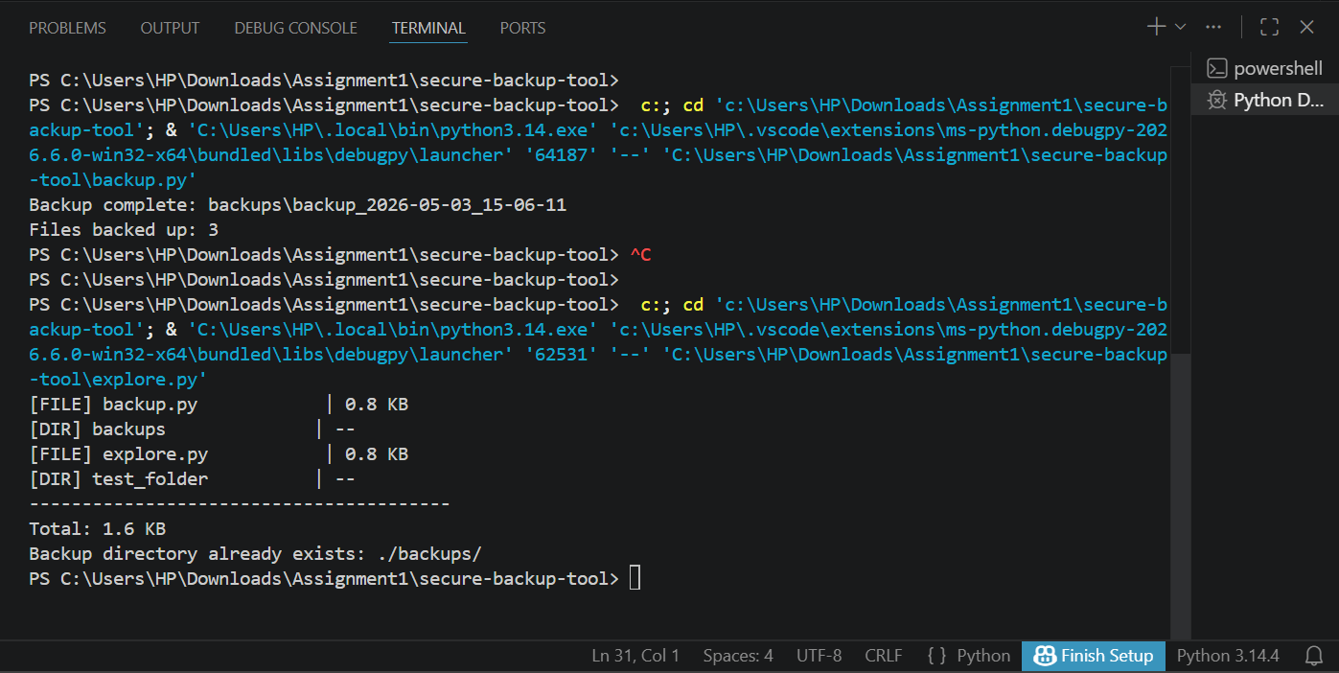
Figure 2 — First successful backup run: terminal confirms backup path and file count

Key observations from this run:
- The backup was saved to backups\backup_2026-05-03_15-06-11
- 3 files were successfully backed up from the test_folder/
- The explore.py scan confirmed the folder structure: backup.py (0.8 KB), explore.py (0.8 KB), plus the backups/ and test_folder/ directories

Stage 3 — ZIP Compression & SHA-256 Hashing
The backup script was significantly upgraded in Stage 3. Instead of copying files as-is, the script now compresses them into a ZIP archive using Python's built-in zipfile module with ZIP_DEFLATED compression. After creating the ZIP, a SHA-256 cryptographic hash is computed over the entire archive and saved to a companion .sha256 file.
SHA-256 (Secure Hash Algorithm 256-bit) is a cryptographic hash function that produces a unique 64-character fingerprint for any given file. If even a single byte of the backup ZIP is corrupted or tampered with, the SHA-256 hash will be completely different. This provides:
- Integrity verification — confirm the backup was not corrupted during storage
- Tamper detection — detect any unauthorized modification of the backup
- Audit trail — a permanent record of the exact state of each backup at creation time
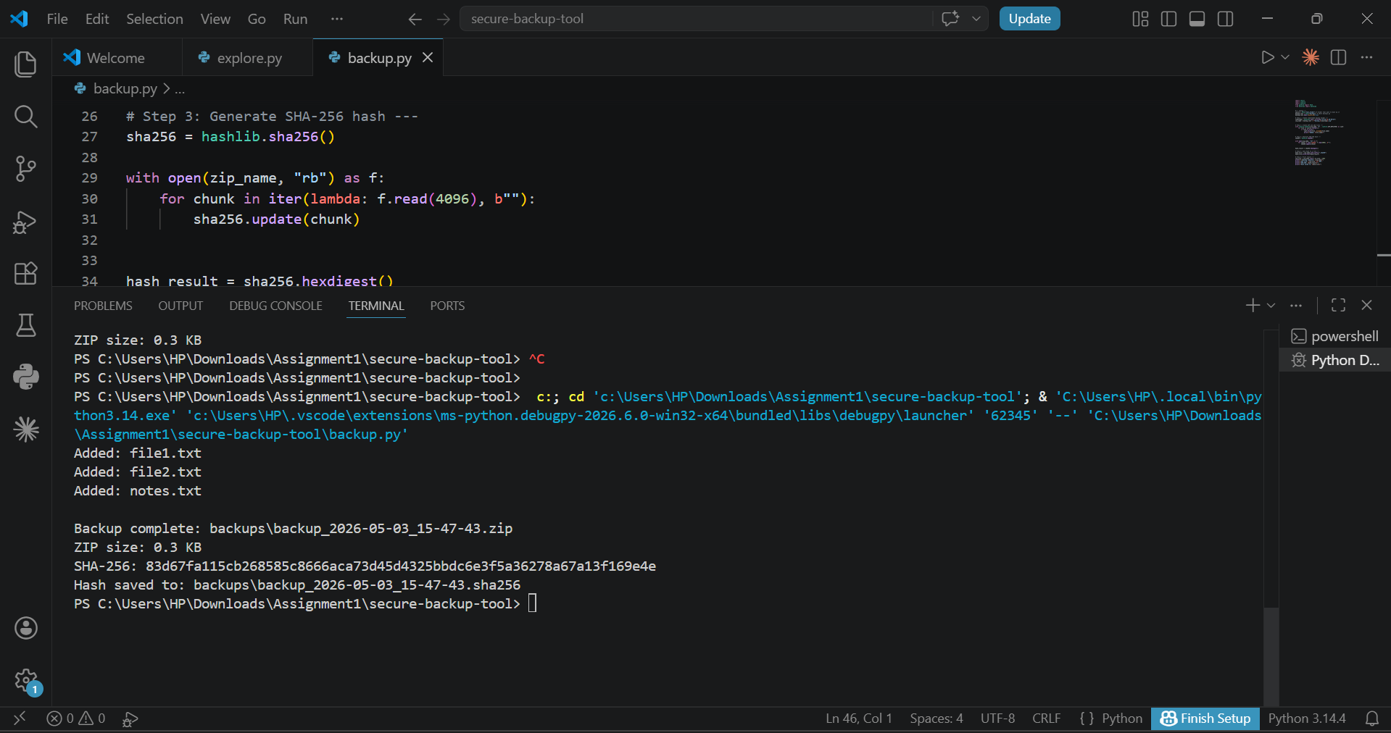 Figure 3 — backup.py with SHA-256 hashing (top) and terminal output showing the generated hash (bottom)
The screenshot above shows the split-screen view: the upper half displays the ZIP creation and SHA-256 hashing logic in VS Code, while the lower terminal confirms the output. The files file1.txt, file2.txt, and notes.txt were successfully added to the ZIP. The SHA-256 hash (83d67fa1...e4e) was generated and saved to a .sha256 file alongside the ZIP.

Stage 4 — Final Version with Logging
The final and complete version of backup.py adds Python's built-in logging module to create a persistent audit log of every backup operation. Each log entry is written to backup_log.txt and records the timestamp, file count, ZIP size, ZIP filename, and the SHA-256 hash.
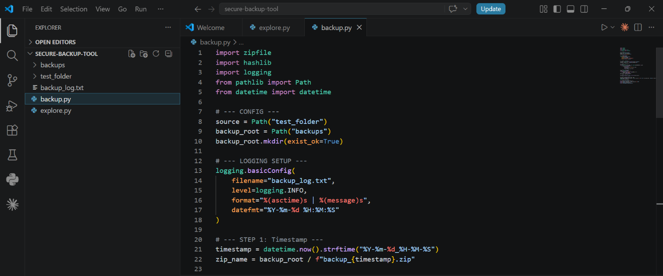
Figure 4 — Final backup.py: complete script with zipfile, hashlib, and logging modules imported and configured
The final script is organized into six clearly commented stages:
- LOGGING SETUP — configures logging.basicConfig() to write to backup_log.txt with timestamps
- STEP 1: Timestamp — generates the backup filename using datetime.now().strftime()
- STEP 2: Create ZIP — iterates source files and adds each to the ZIP with ZIP_DEFLATED compression
- STEP 3: SHA-256 Hash — reads the ZIP in 4 KB chunks and feeds them to hashlib.sha256()
- STEP 4: Save hash — writes the hex digest to a .sha256 companion file
- STEP 5: Log the backup — writes a structured log entry via logging.info()
- STEP 6: Print summary — prints a human-readable summary to the terminal

Final Output — Terminal & Log File
The terminal output below shows the final version running successfully, with all six stages completing in sequence. The output confirms the files added, the backup path, file count, size, SHA-256 hash, and that the log was updated.
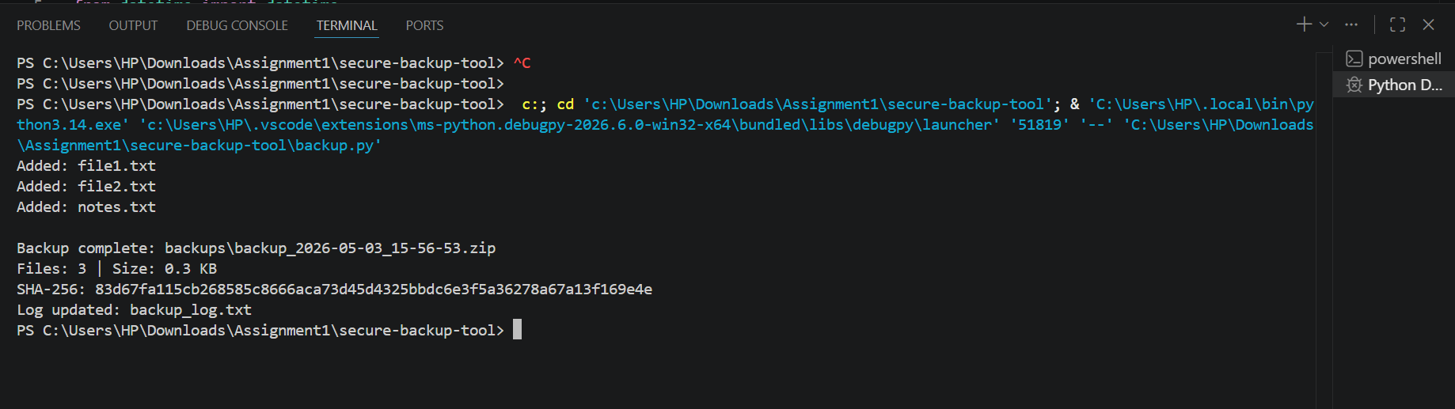
Figure 5 — Final terminal output: files added, backup path, SHA-256 hash, and log confirmation
The terminal output demonstrates all expected results:
- Three files (file1.txt, file2.txt, notes.txt) were successfully added to the ZIP
- Backup saved to: backups\backup_2026-05-03_15-56-53.zip
- Files: 3 | Size: 0.3 KB
- SHA-256: 83d67fa115cb268585c8666aca73d45d4325bbdc6e3f5a36278a67a13f169e4e
- Log updated: backup_log.txt

Persistent Backup Log(Backup_log.txt)
The backup_log.txt file provides a persistent audit trail of all backup operations. Each line represents a single backup run and contains the full metadata in a structured, pipe-delimited format that can be parsed or reviewed easily.
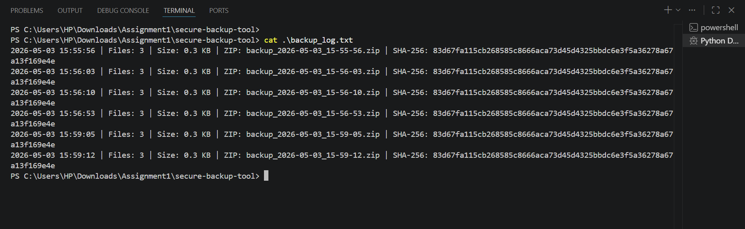
Figure 6 — backup_log.txt showing six sequential backup entries with timestamps, sizes, ZIP names, and SHA-256 hashes

